SIMATS ENGINEERING
ASSESSMENT TOOL 1 – Constraint Based problem solving

COURSE NAME: STATISTICS WITH R PROGRAMMING COURSE CODE: ITA04

COURSE OUTCOME COVERED

CO 1: Apply R programming fundamentals including data structures, vectors, matrices, arrays, and class types to perform mathematical operations and manage data effectively.(Bloom Level-BL2-BL4)

Assessment Tool Weightage: 20%

Constraint-Based Problem Solving
1. Student Performance Analysis
A college maintains the marks of 10 students in Mathematics, Physics, and Chemistry. Develop
an R program using a matrix while ensuring that marks are within the range of 0 to 100 and
handling cases where multiple students obtain the same highest or lowest marks.
(a) Store the marks of the students in an appropriately labelled matrix and calculate the
subject-wise average marks.
(b) Identify the highest and lowest scorer in each subject, considering cases where more than one
student has the same marks.
(c) Calculate the overall average marks and display the students whose average is greater than
the overall average.

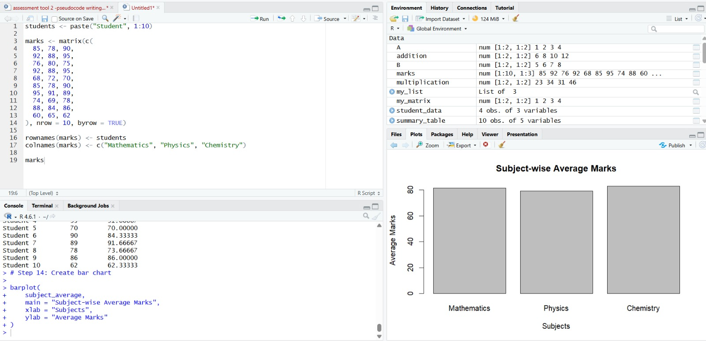

2. Employee Salary Processing
An organization maintains employee information including Employee ID, Name, Basic Pay, and
Allowance. Develop an R program using suitable data structures while ensuring that Employee
IDs are unique and salary components are non-negative.
(a) Calculate the Gross Salary of each employee as Basic Pay + Allowance.
(b) Identify employees whose Gross Salary is greater than ₹50,000 and display the employee or
employees having the highest salary.
(c) Generate a summary report containing the total number of employees, average salary, highest
salary, and number of employees earning above ₹50,000.

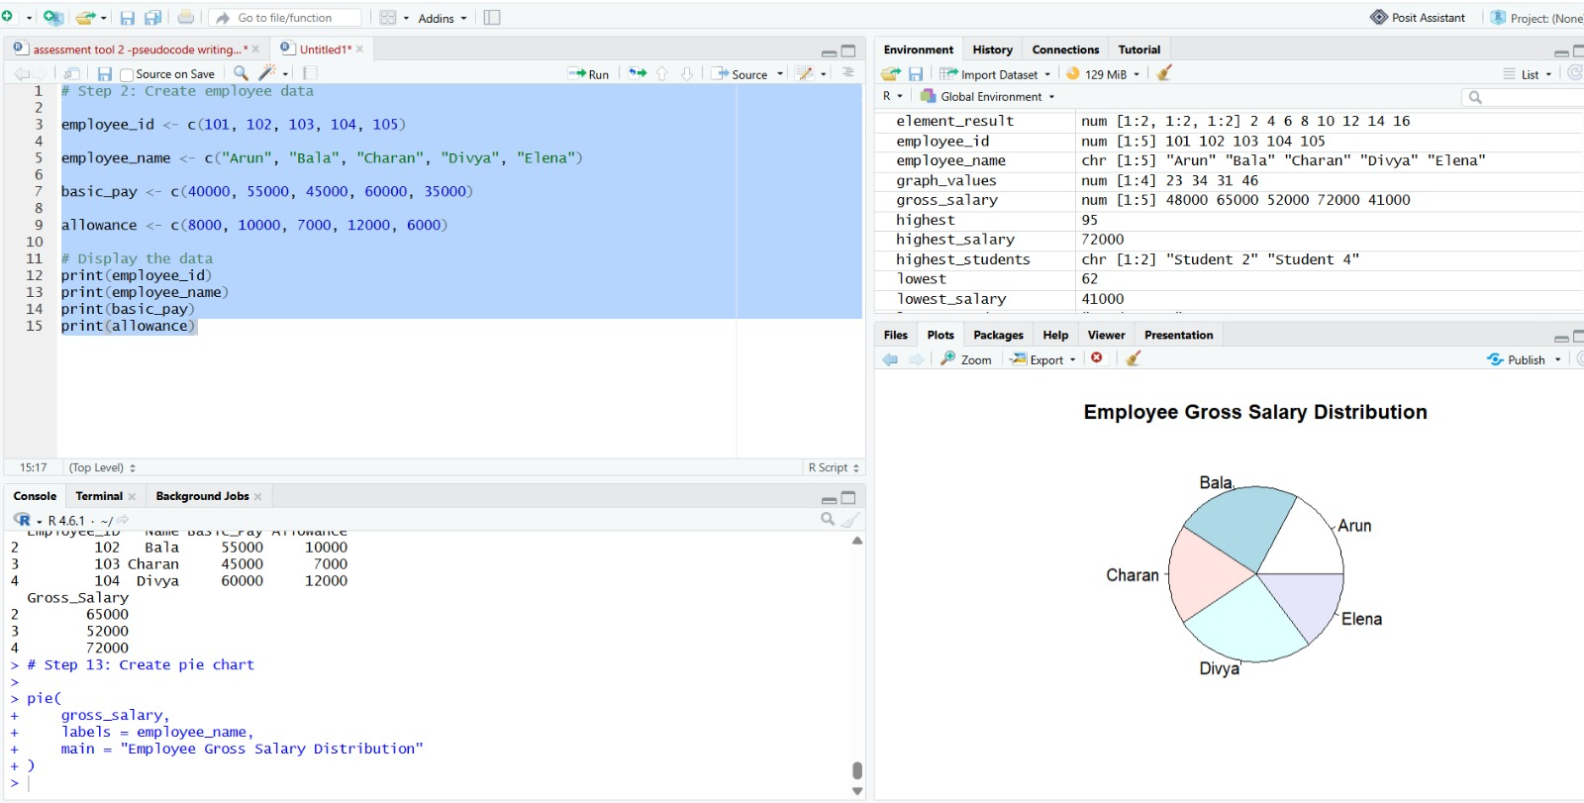

3. Weather Data Analysis Using Arrays
A weather monitoring system records the daily temperature of three cities for seven days.
Develop an R program using a 3-dimensional array while ensuring that temperature values
remain within the range of -10°C to 50°C. (a) Store the temperature data in a 3-dimensional array and calculate the average temperature for
each city.
(b) Identify the city and day on which the highest temperature was recorded, including all
locations in case of a tie.
(c) Compare the temperature variation among the cities using their minimum, maximum, and
average temperatures.
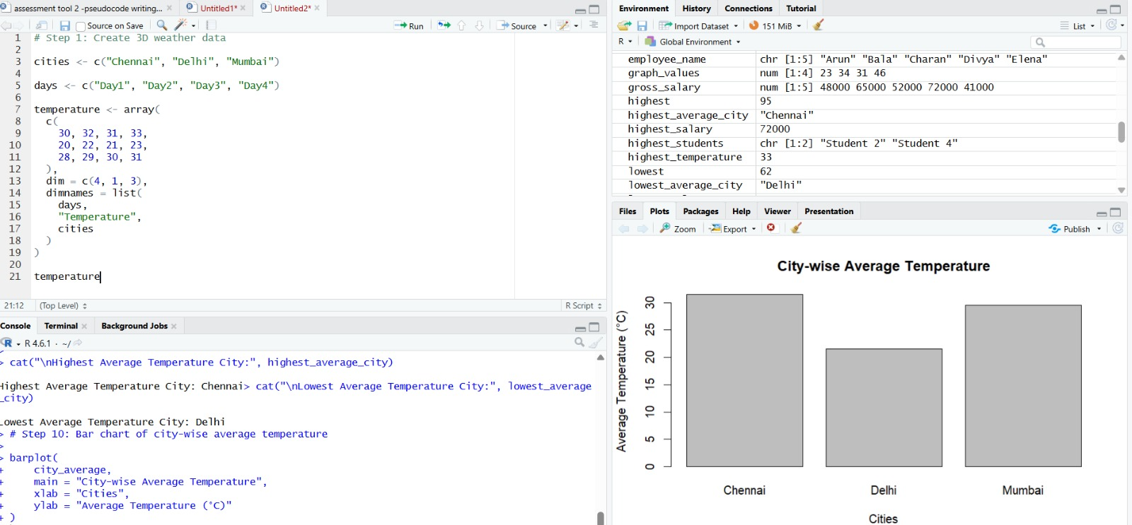

4. Product Inventory Management
A retail store maintains Product ID, Product Name, Quantity, and Price using lists and vectors.
Develop an R program while ensuring that Product IDs are unique and quantity and price values
are non-negative.
(a) Calculate the inventory value of each product using Quantity × Price.
(b) Identify and display all products whose stock quantity is below a specified threshold value.
(c) Generate a stock summary containing the total number of products, total available quantity,
and total inventory value.
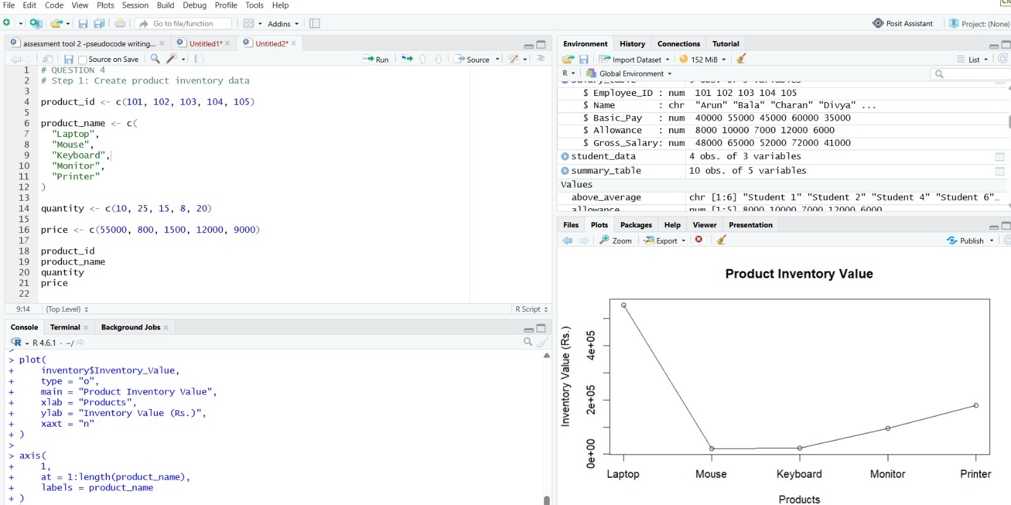

5. Bank Account Processing Using Functions
A bank requires an account processing system that performs deposit, withdrawal, balance
checking, and transaction history operations using user-defined functions. Deposit and
withdrawal amounts must be positive, and a withdrawal cannot exceed the available balance.
(a) Develop separate R functions for depositing and withdrawing money while ensuring that
invalid transactions do not modify the account balance.
(b) Develop a function to check and display the current account balance after every successful
transaction.
(c) Maintain and display a transaction history containing the transaction type, transaction
amount, and balance after each successful transaction.
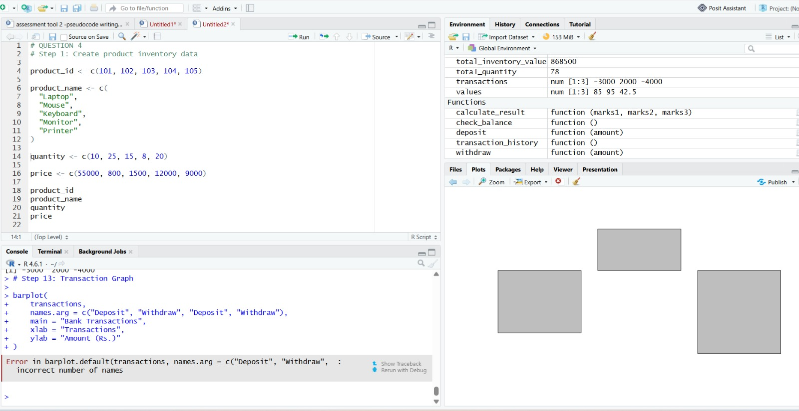

6. Hospital Patient Data Analysis
A hospital maintains patient information including Age, Gender, and Treatment Cost in an R data
frame. The system must ensure that age and treatment cost contain valid non-negative values and
that missing data is handled appropriately.
(a) Store the patient information in a data frame and calculate the average treatment cost for
valid patient records.
(b) Identify and display patients whose age is greater than 60 years while appropriately handling
missing age values.
(c) Generate statistical summaries for patient age and treatment cost and identify missing or
invalid observations.

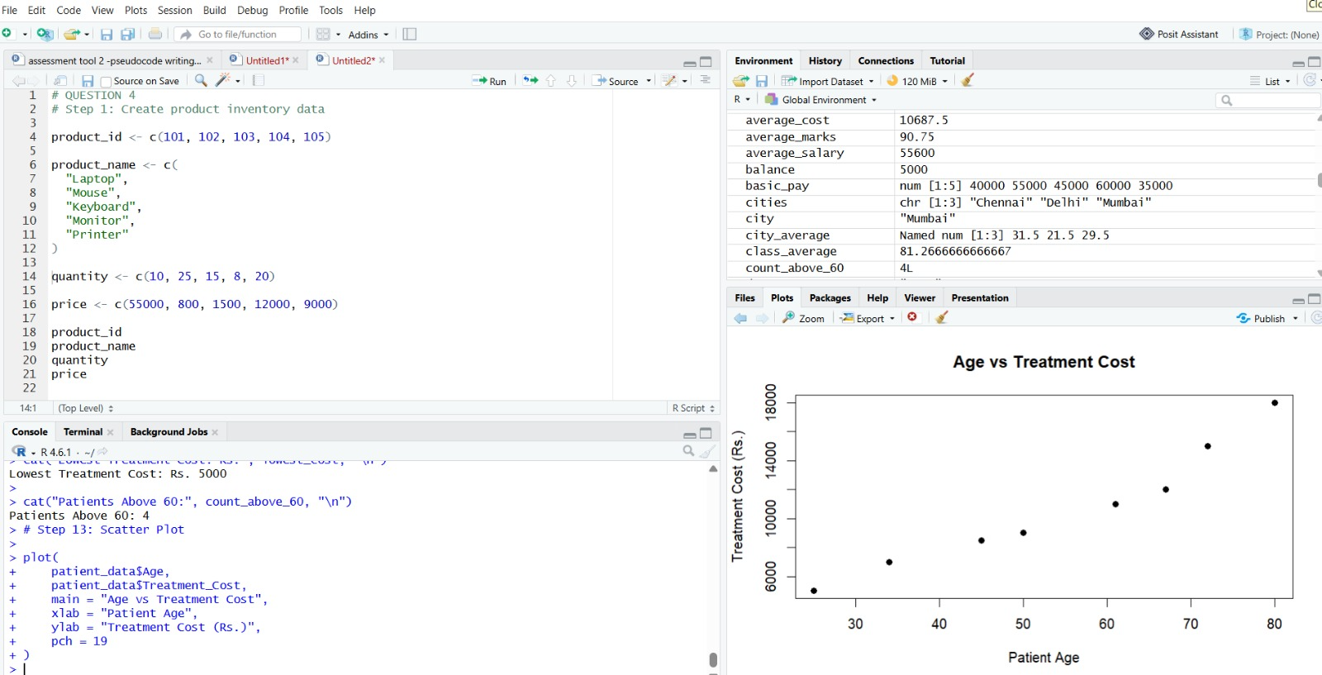

7. Logical Vector-Based Voting Eligibility System
A civic organization maintains the Name and Age of citizens and wants to determine voting
eligibility using logical vectors. A citizen is eligible only when the age is at least 18 years, while
missing age information must be handled separately.
(a) Create a logical vector to determine the voting eligibility status of each citizen based on the
age constraint.
(b) Count and display the number of eligible and ineligible citizens while handling missing age
values appropriately.
(c) Calculate the percentage of eligible voters among citizens having valid age information. 8. Matrix-Based Sales Analysis
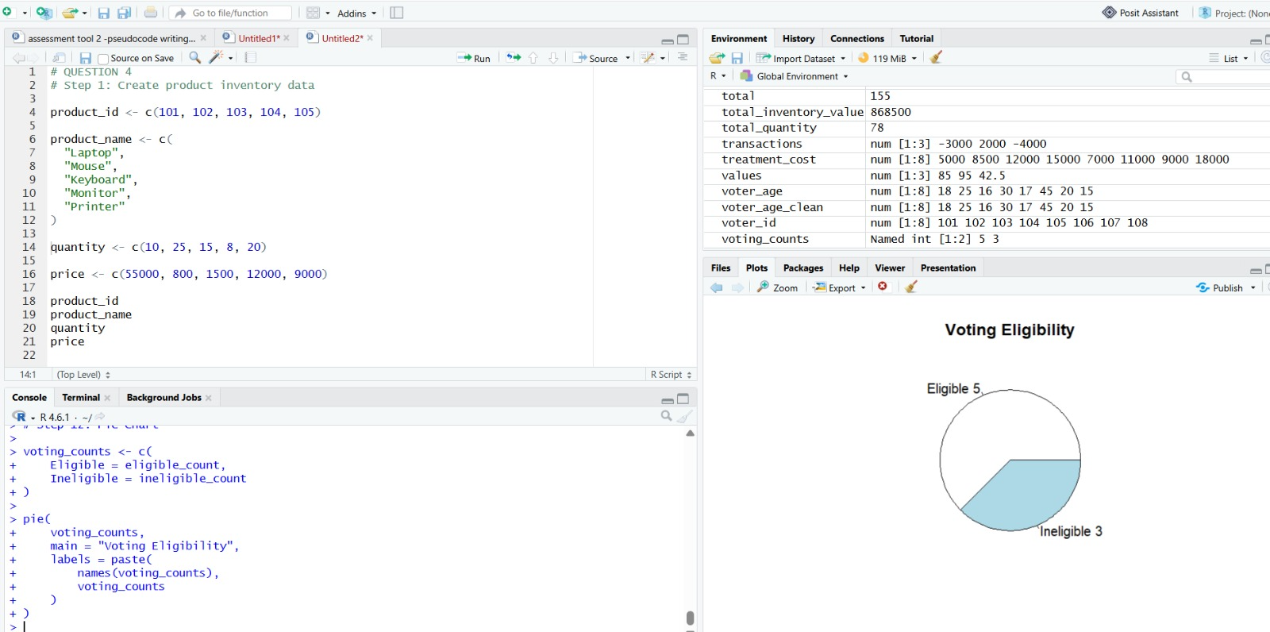

A company records monthly sales of four products across three regions using a matrix. Sales
values must be non-negative, and the program must handle cases where multiple products or
regions have the same maximum sales.
(a) Store the sales information in a properly labelled matrix and calculate the total sales for each
region and product.
(b) Identify the best-performing product based on total sales and display all products if a tie
occurs.
(c) Identify the region with maximum sales and generate a summary containing total sales and
average sales.
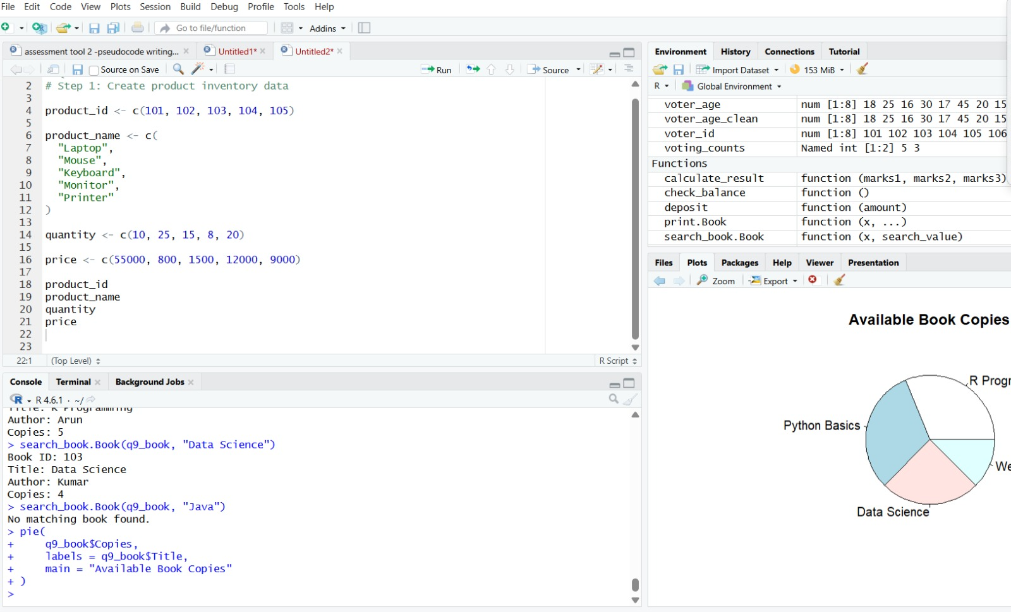

9. Library Management Using S3 Class
A library wants to manage book information using an S3 class named Book, containing Book
ID, Title, Author, and Number of Copies. Book IDs must be unique, and the number of available
copies must never become negative.
(a) Create the S3 class and implement a method to display complete book details.
(b) Develop a method to update the number of available copies while preventing values that
result in a negative number of copies.
(c) Develop a search operation to locate a book using Book ID or Title and display an
appropriate message when no matching book is found.

10. University Information System Using S4 Class and Reference Class
A university wants to develop a student information system using an S4 class named Student
with Roll Number, Name, and CGPA, along with a Reference Class for managing student
records. Roll Numbers must be unique and CGPA values must remain within the range of 0 to
10.
(a) Create the S4 Student class and develop a mechanism to add new student records while
preventing duplicate Roll Numbers.
(b) Develop an operation to modify the CGPA of an existing student while rejecting invalid
CGPA values and display the updated student details.
(c) Find and display all students whose CGPA is greater than 8.0, and display an appropriate
message when no student satisfies the condition.
